Scala Programming

Name : Madhusshree.S

Usn : 22btrad022

Lab 1:

Scala Installation

Step 1:

* Scala runs on JVM. Therefore our first step is to check if Java is installed in the laptop.
* Type the following command in the command prompt.
* >>> java -version
* Using this we’ll know if java is installed or not.
* If not, go to Java’s website and download java for windows version as shown below.

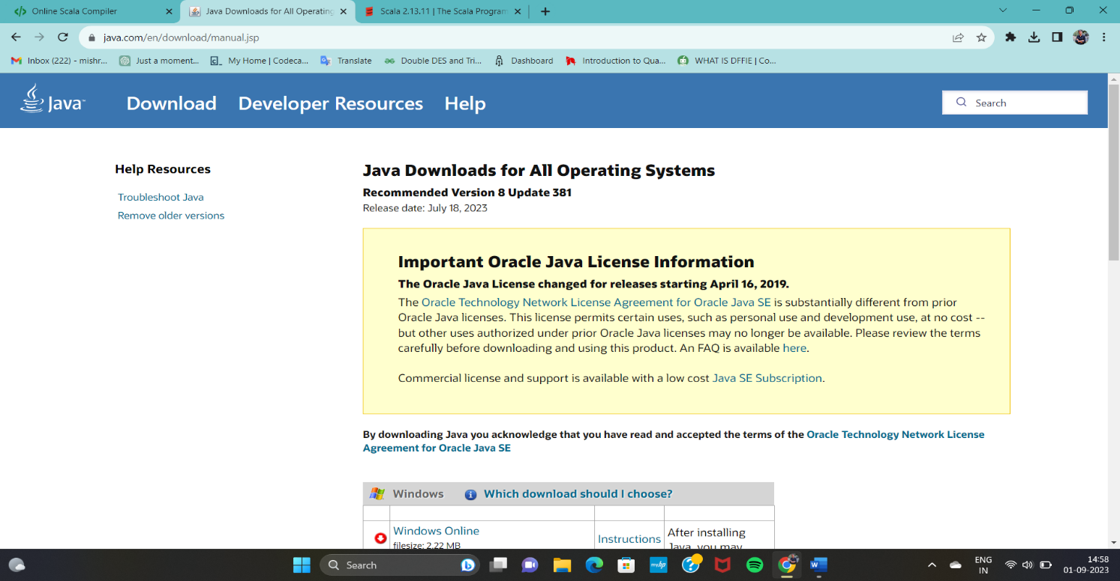

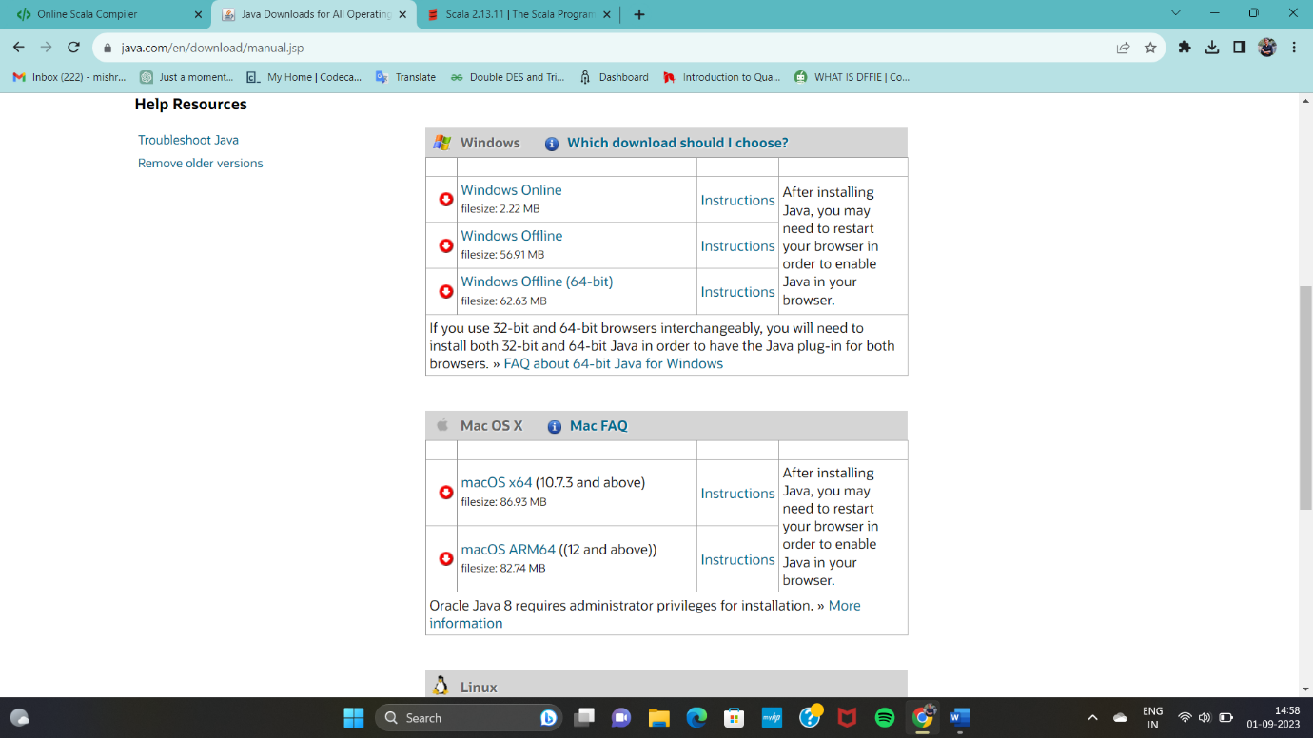

Step:2(Downloading Scala)

* Go to Scala’s official website and go for downloading the latest version of scala 2.13.11.
* Once you click on it, you’ll be directed to the page as shown below.

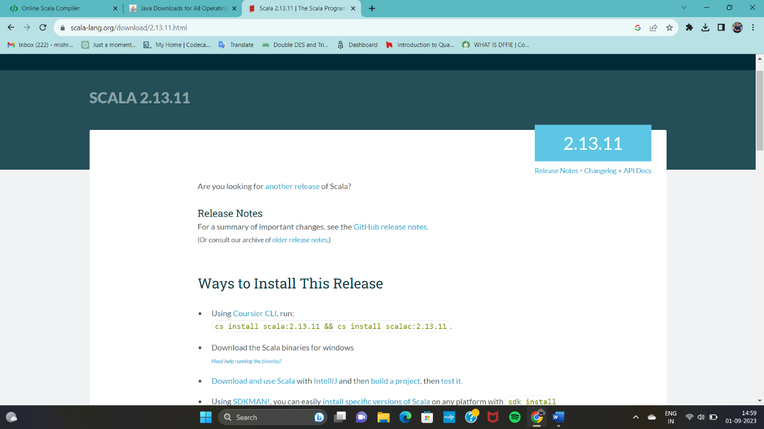

* Next, look for the suitable versions and bits and download the same. Look for msi(windows installer)and click download

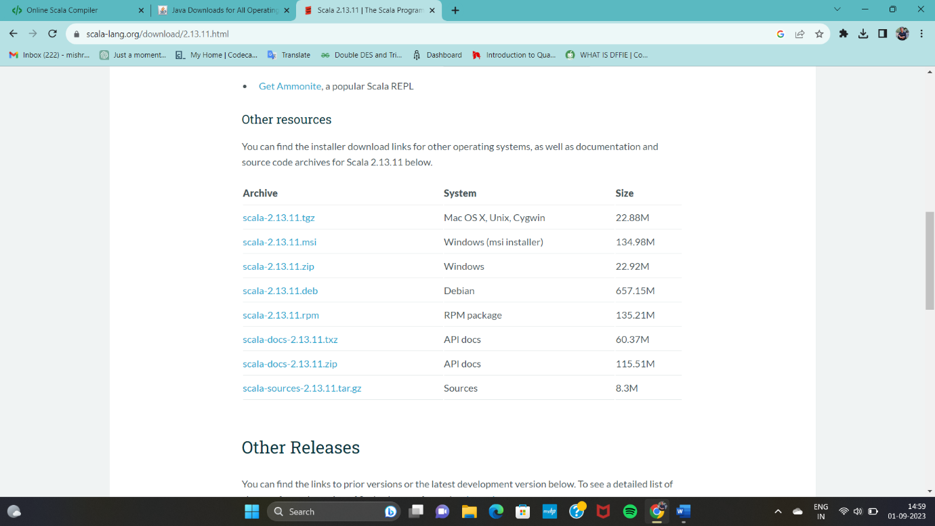

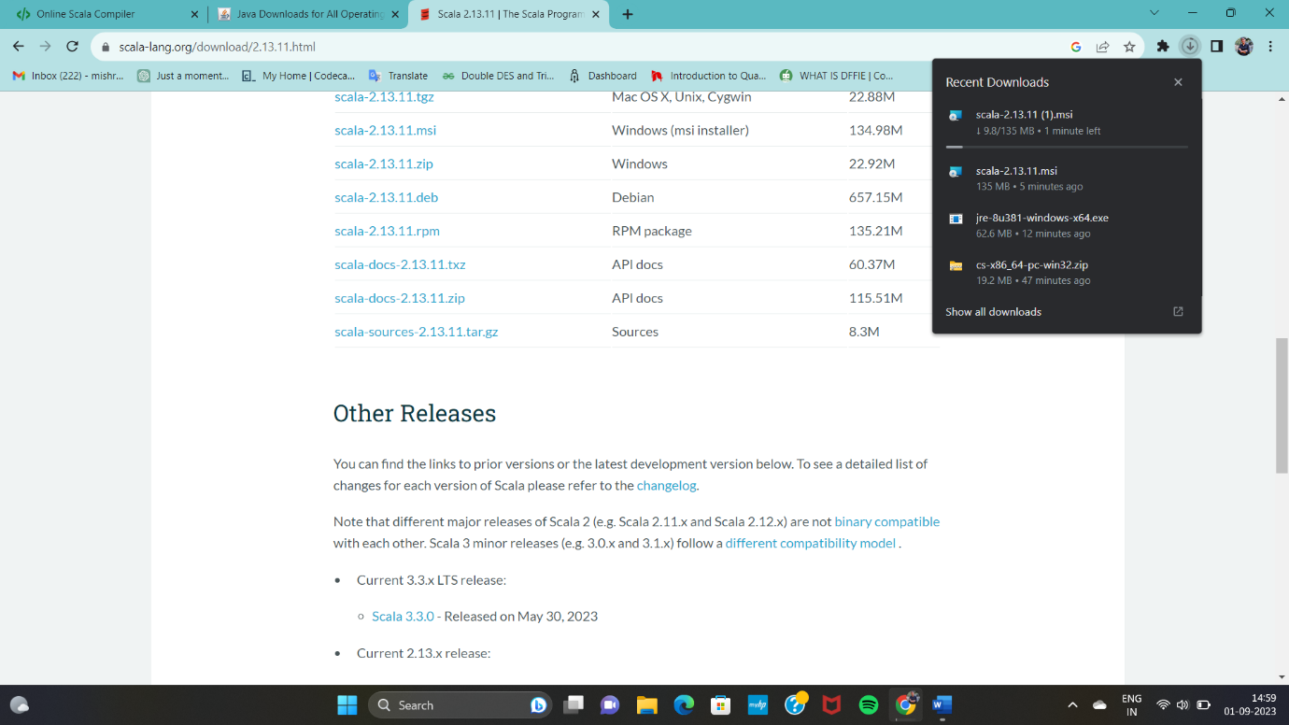

* After downloading, go for installation selecting the basic default options.

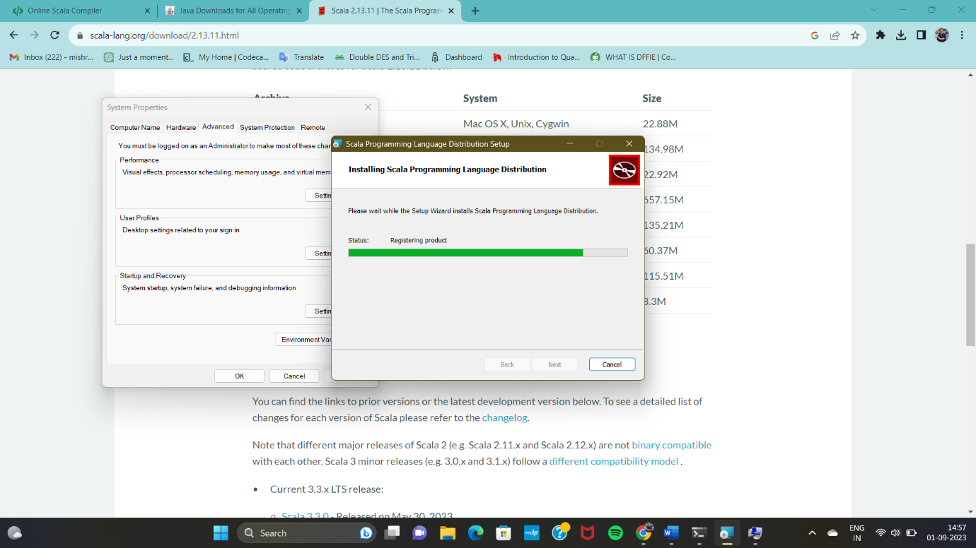

* After installation go for path variables in system properties.
* Edit the environment variables. Go to path. Copy and paste the same in the path.
* Once done, select finish. Now the installation is complete.

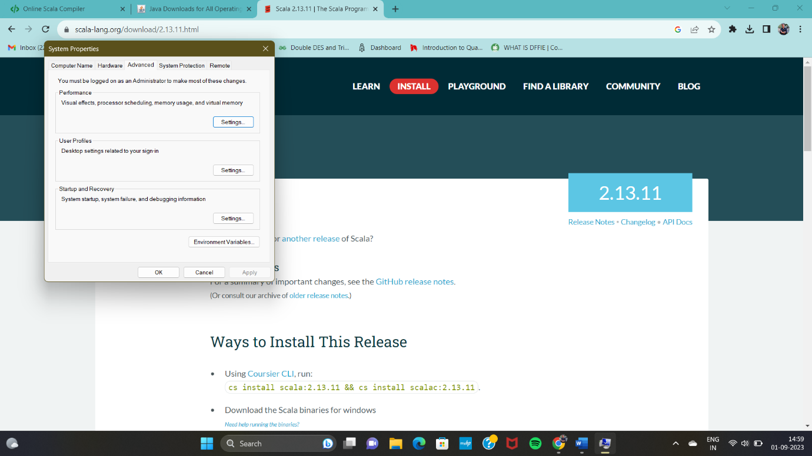

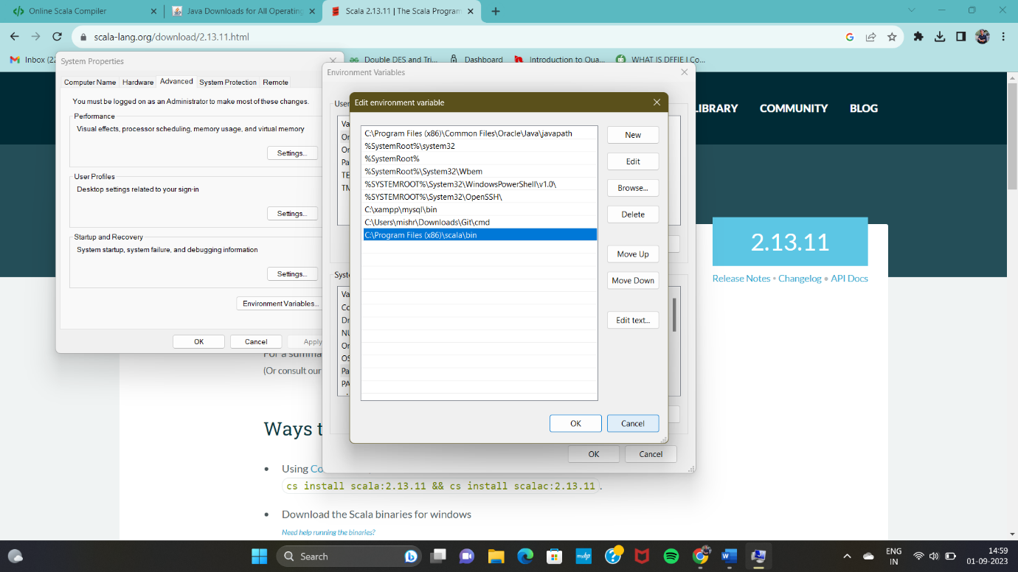

* After installation, restart the laptop.
* Now, go to command prompt and type
* >>>scala (and press enter)
* Now it will lead us to Scala where we can directly type commands using the command prompt rather an IDE.

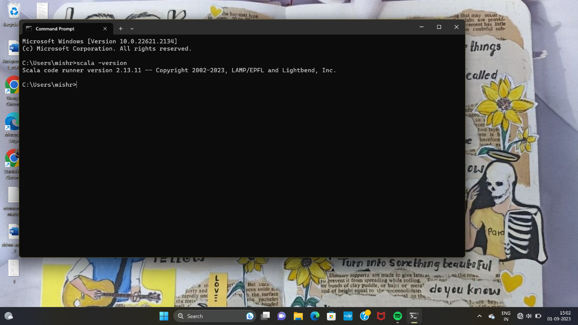

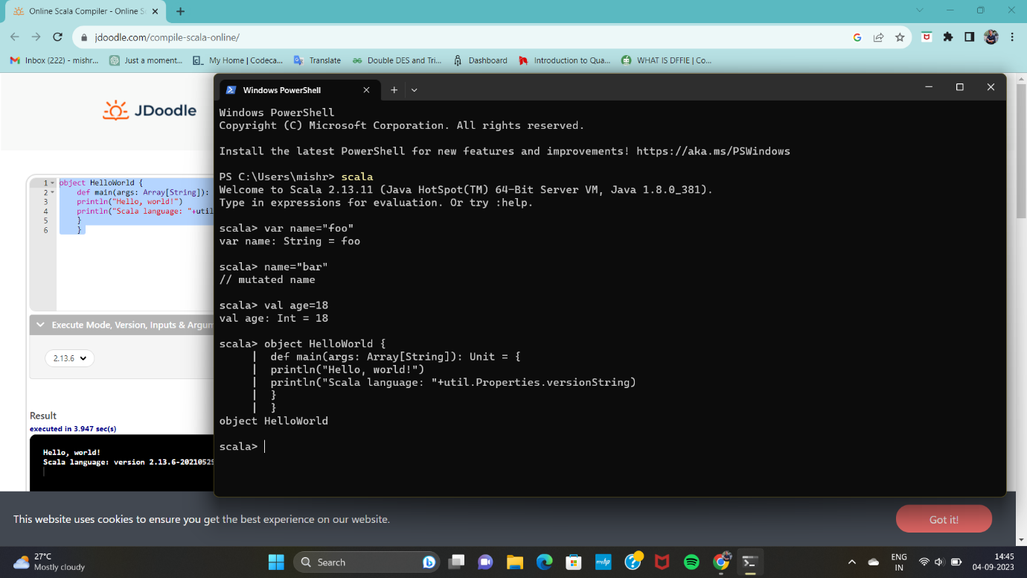

-------------------xxxxxxxxxxxxxxxxxx---------------------